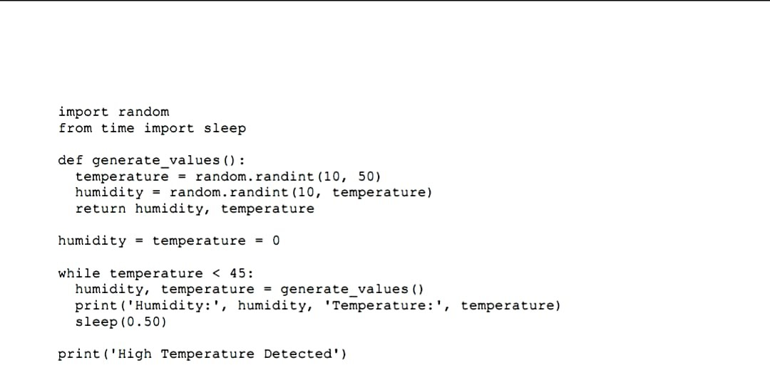**Team ID:PNT2022TMID13705**